Results of Survey for Vision Academy

Introduction of the survey:
Vision Academy aims to offer courses that address practical issues that challenge our youth (e.g., marriage, career, evangelism, social justice, loneliness, depression, personal finance, meaning of life, life after death, ...). We hope to provide a learning platform for our youth, especially those who are in small ministries, where they feel welcome and interact with their peers around the world. The lead-instructors for the courses are seasoned professionals and they will make the courses interesting by inviting other guest speakers.

Please take a few minutes to answer the questions below. Your input is very important to us in planning our future courses. Thank you!

------------------------------------

Results of the survey

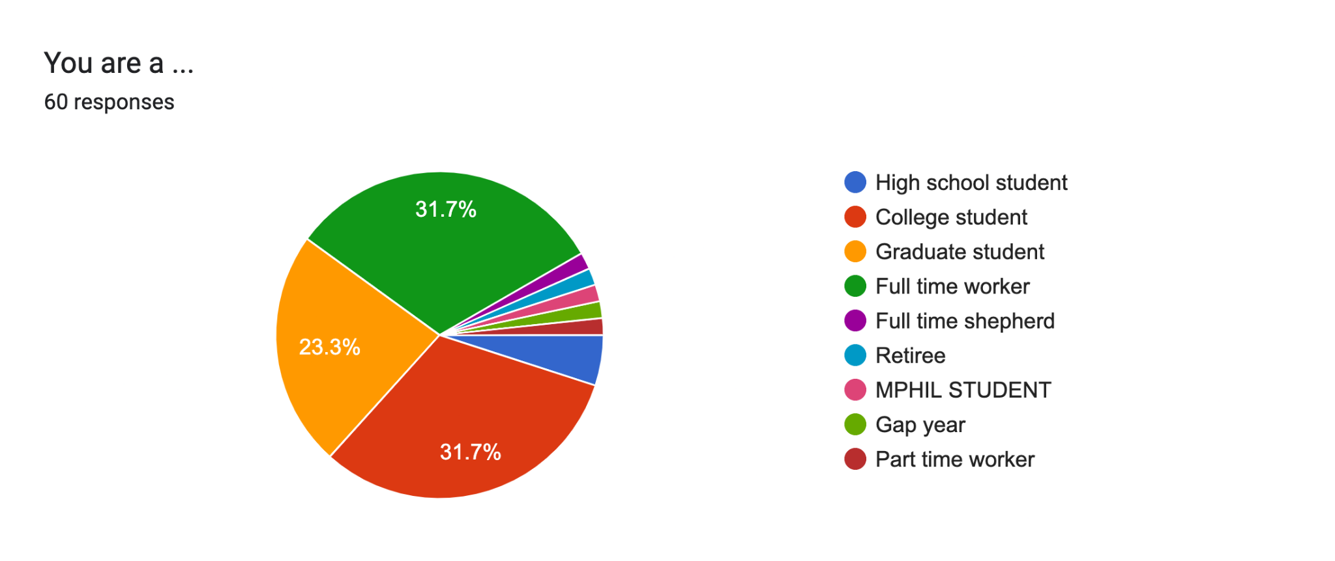
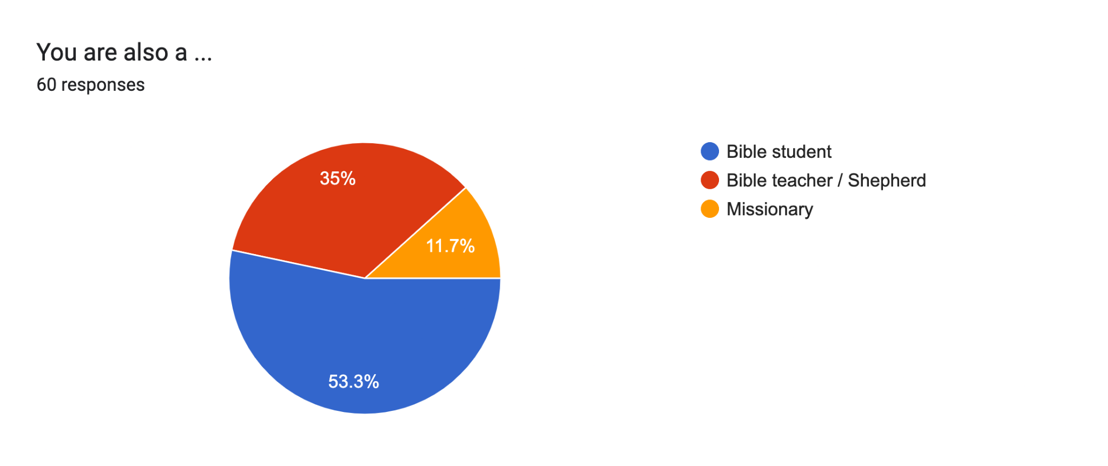

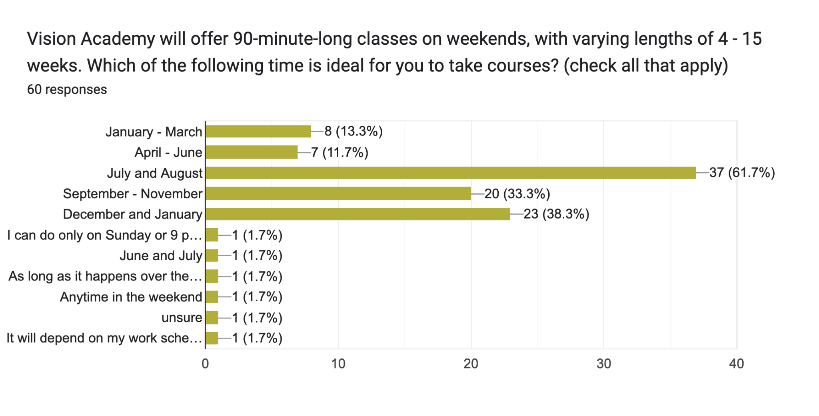

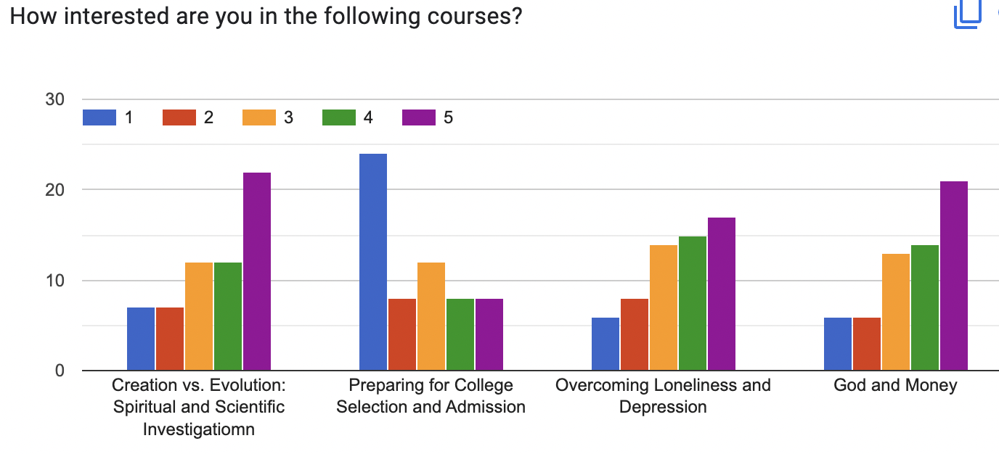
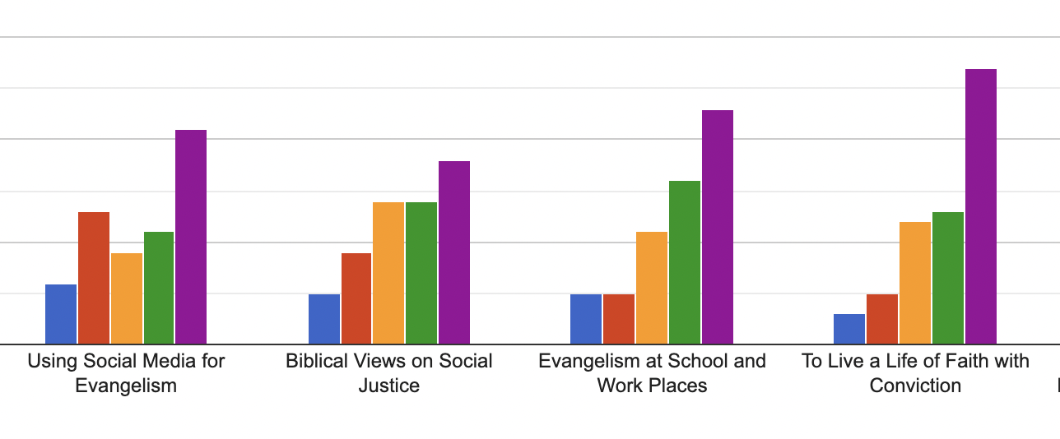
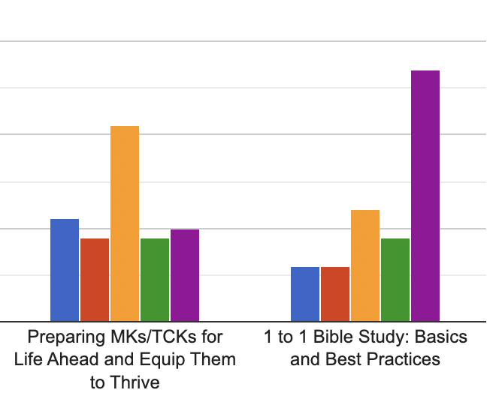
Any course(s) you would like to see offered by Vision Academy?
- Relationship with God
- 목양 상담 스킬,Generation gap 극복방법
- Straight vs gay, what is the evidence for and against homosexuality, bisexuality.
- How to walk in the faith in our modern world; Personal finances; idol worship; How to maintain and have an active prayer life; how to practially live and engage in spiritual battles
- How to prepare Bible study materials; how to teach the Bible one to one--curriculum
- Walking with God
- Prayers and fasting
- Ways to create fellowship and networks for the children for internship and mission trip
- Practical example of a fruitful ministry
- Less class but offline camp
- Biblical womanhood, true faith in the Lord even when it looks like the world is winning. What is salvation and why we need it.
- A course about biblical womanhood
- How to share the gospel among our circles
- How to become a spiritual man?
- Living by faith on a marriage
- Dealing with your romantic feelings
- have any preferenceRemaining faithful in a crooked generation
- Healthy prayer life
- Special guests?
- Aligning one's career with God's mission
- The bible’s view on what we do to our bodies
- How to be a good christian praise worshiper. Praise composition courses
- Sexuality, gender identity, womanhood
- Intro to Christianity, Shorter Catechism
- Chrstian conduct
- Biblical sexuality, what does it mean to be a man/woman
- Intimacy with God
- Christian living
- Involvement of Christians in politics
- Dating, love, marriage by faith
- Financial literacy and how manage finances in marriage
- About how build healthy relationships (family, church, work, friends) and about Healthy lifestyles
- Creation vs evolution
- biblical counseling
- Prayer Living
- How do we understand crimes/criminal injustice in society in God’s perspective? How can we deal with anger and helplessness that comes from war, violence and corruption?
- spiritual leadership
- Christian perspective on sexual orientation
- 1 to 1 Bible Study : Basics and Best Practices

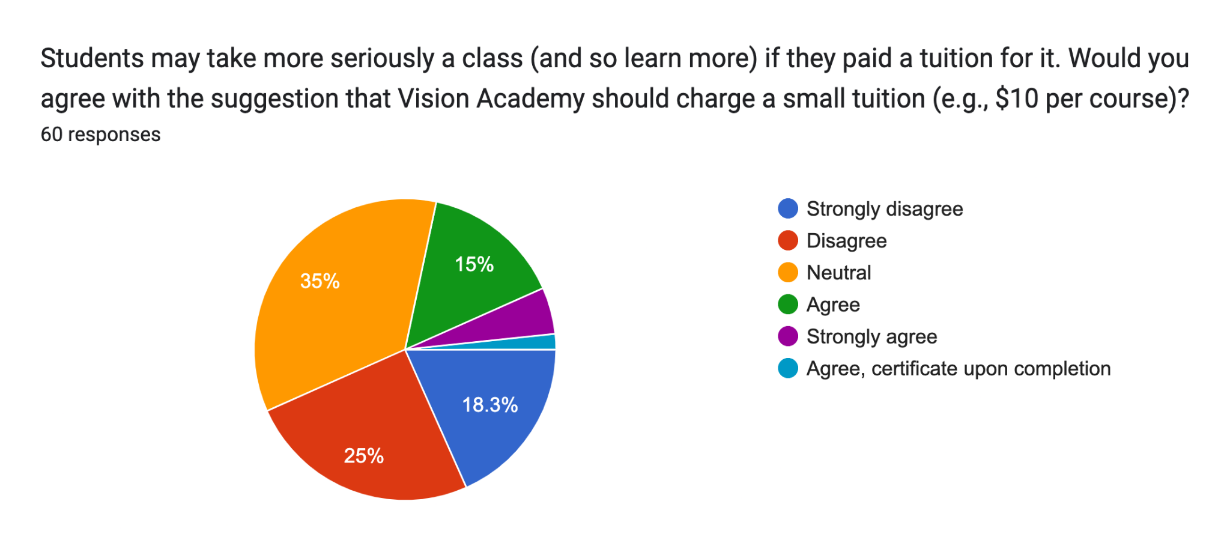
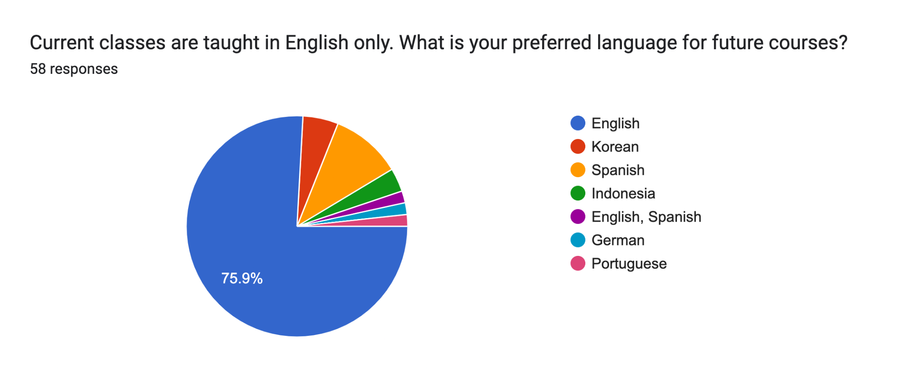

Any suggestions or comments for Vision Academy? (You can also post your comments anytime at "Our Community" on our website, https://academy.visionubf.org)

- Focus on deep relationship with God
- 더 많은 광고로 동역자들에게 이런 강의가 있음을 알려주세요
- Full concentration for helping next gens to encounter Jesus personally
- Praying time is not effective as bible study
- Making people pay would make it like any other course. Losing that reliance on God during the course. We could play small online games in breakout rooms as ice breakers to better know each other, in those groups also give our prayer topics so we can pray for each other. I'm so grateful that it wasn't like a bible study. The teacher was fun, funny and knowledgeable.
- Thank you for allowing God to use you for His work
- Thank you for the good work in bible teaching and instruction
- I think its a great way for the youth to learn the ways of the lord
- Very effective and educational
- the courses could be in half Spanish half English for those of us who are just learning English
- Feeling a bit guilty about the “students may take a course more seriously if they paid a tuition” question above. I was not able to attend two sessions out of four due to personal circumstances and time zone issues but I think that the fact that sessions were more flexible / recordings were provided helped me get the most out of what I could. Shouldn’t give too much pressure with assignments and participation, though encouraged.
- If we can set up a communication channel like Discord or Slack
- its a good classes
- Congratulate you for your hard work, please promote these courses through all chapters and open more courses. Thank you!
- Various(more) classes to choose

